


Plastic Cups and Yogurt Pots:
- Cut opaque/white ones into strips, point the ends, write on them with an indelible pen for plant labels
- Cut bottoms off, bury cut edge into soil around small plants - mini slug cloches keep the beasties off.
- Poke a few holes in the bottom, fill with compost and use to grow large seeds such as broad beans, peas and runner beans.

Plastic Food Trays of the kind fruit, veg, takeaways and meat come in from the supermarket
- Poke holes in the bottom, fill with compost - makes seed trays for seeds of which you only need a small quantity such as tomatoes, peppers, chillies. Flimsy trays can be stacked one inside another.
- Use to harvest small fruits such as raspberries, gooseberries and blackcurrants.
- Use to store plant labels, pens, odd and ends in your shed or greenhouse.

Plastic Milk Bottles
- Cut off bottom and make angled cuts along 3 sides. With the handle in tact it now makes a good scoop for compost etc.

Clear Plastic Squash Bottles, Water Bottles, Juice Bottles etc.
- Cut off tops, make a few small holes in the bottom and sink into ground next to vegetable/flower plants, fill with water. Water will be absorbed into soil slowly and in just the right place for the plant.
- Cut off bases and use as cloches to protect young plants from weather and slugs. Unscrew and take off lid during day, replace at night until plant is established.
- Cut in half and use as cloches over your seed trays to keep seeds and young plants warm and cosy.

Bubble Wrap
- Use as extra insulation in a greenhouse.
- Use as insulation around patio pots left outside in cold weather, both around the pot and the foliage.
- Cover seed trays and plants overwintered in green houses/polytunnels to protect from cold.

Newspapers
- Lay over the soil thickly between plants and then cover with grass cuttings. Great way to supress weeds and it will rot down over the course of a season and fertilise your soil too.
- Roll several layers into a tube around a rolling pin or piece of wood, tuck in one end - use as a plant pot for large seeds such as runner beans. The pot will rot down naturally and does not need removal.

Ladies Tights
- Cut laddered tights into strips - use as soft garden ties for your plants that will not chafe the stems.
- Place foot end of old tights/pop socks over garden pond filters and drains to stop leaves and debris being washed into them.

CD’s and DVD’s
- Hang by string from trees, canes, plant supports in your beds, and from foilage and stems of bushy plants to deter bird damage to fruit, flowers and leaves. Cut out a picture of the relevant plant and paste onto the CD to make your bird scarer more decorative and informative.

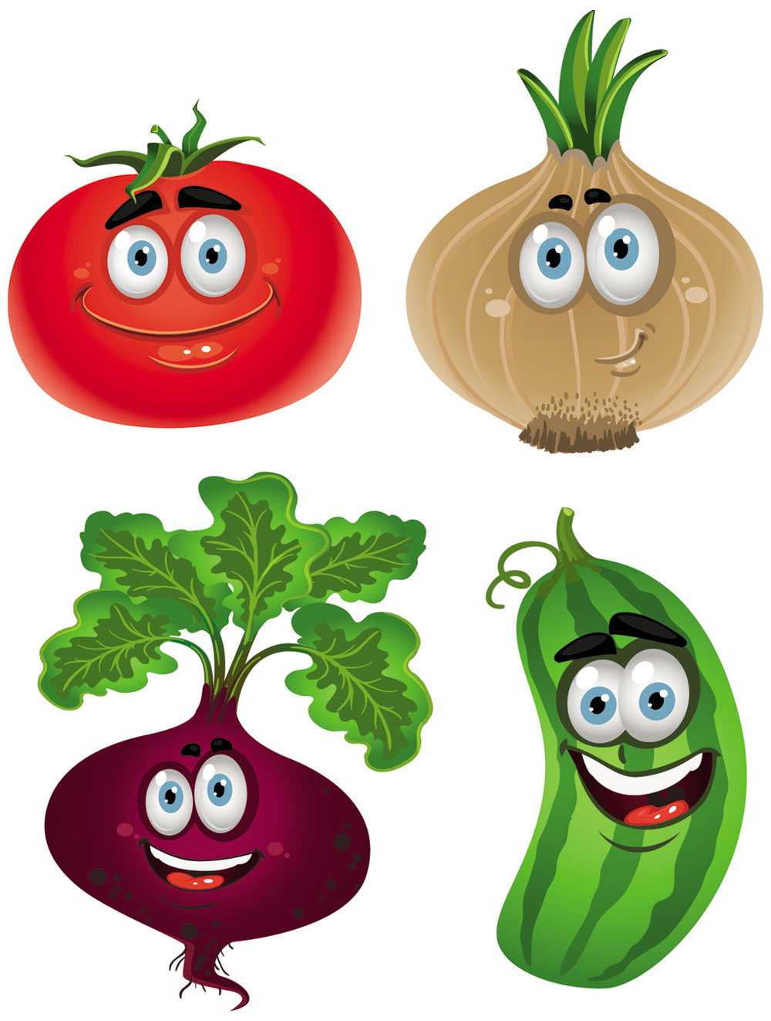
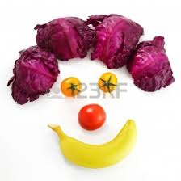

Toilet roll and kitchen roll centres
- Use for sowing seeds. Stack empty tubes tightly together in a plastic tray to support one another and fill with compost. They are longer than a regular pot.
- This makes them excellent for seeds with long root growth such as peas, leeks, sweet corn, runner beans, french beans.
- Also good for seeds that hate disturbance when they are planted out such as parsnips, carrots and beetroot as you can plant out the seed within its ‘pot’ which rots down in the ground as the plant’s root system grows.

Old Tin Cans
- Wash out the can, punch a few holes in the bottom with a screw driver and hammer and paint the outside with any coloured household paint, including samplers, sitting around in your shed or garage.
- Put some old crocks or stones in the bottom, fill with compost and arrange your tins together in an old crate, on a ledge, by your backdoor, in a neglected corner etc.
- Fill with small herb and flowers plants. Can make a stunning addition to your summer garden and looks very ‘continental’!!

Cardboard Boxes – to supress weeds very effectively
- Flatten out, remove any packaging tape and lay over soil between rows of veg plants, in flower beds etc making sure to overlap edges so no light gets between them.
- Cover with a layer of bark, compost, leaf mould or grass cuttings. Rots down over course of a season.

Wooden wine crates and vegetable boxes, plastic mushroom crates etc.
- Use to store onions, shallots, pumpkins etc over winter. Air flows through gaps and helps stop rot.
- Fill or use as a stand for painted tins and/or different sizes of decorative plant pots to make a garden stand and display.
- Use to collect your garden produce from your plot.

Rubber Tyres
- Stack 2 or 3 together and fill with compost to make a planting bed.
- Cut up with a saw and strong knife and nail pieces around the corners of wooden raised beds to prevent ‘barked’ shins.

Carpet
- Old discarded carpet can be laid over a patch of ground you need to clear of weeds or grass such as a neglected allotment bed or site of a new garden veg or flower bed.
- Weighted down and left for a year it will completely cut out the light and kill off the majority of the weeds including bindweed and dock.
- If the carpet is woollen it will eventually rot away and fertilise the soil if left long enough, but carpets with foam backing or made from a blend of wool and man made fibres must be removed and disposed of when they have done their job.

