SusCred Woodlands and Hedgerows group – Poltimore site
This work is for a group managing a small wildlife area in the churchyard at Poltimore. We are authorised to do the work by Poltimore Parochial Church Council.
An overgrown beech hedge at one end of the churchyard is to be reduced to 4 feet high. We are going to start with the small section immediately overlooking the wildlife area as the other section has access and safety complications.
There are about 20 stems to be felled and the largest is about 12 inches in diameter. We may need a felling bar and a rope. Brash will be removed by wildlife area volunteers. The church yard is adjacent to the road and we can, with care, park outside the churchyard. If we can get a gate unlocked we may have very direct access from the worksite to the road.
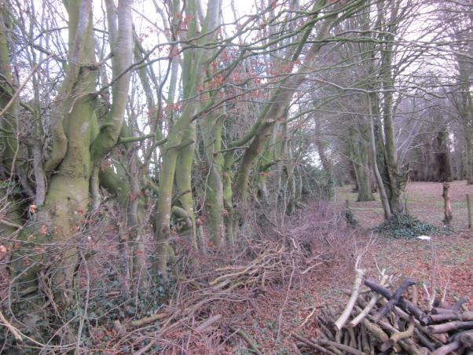
Poltimore is at EX4 0AT.
Suggested route from Crediton:
A377 to Cowley Bridge
Turn left on A396 towards Tiverton.
At beginning of Stoke Canon village, before pylon, take sharp right up hill through woods.
At top of hill (Stoke Post) turn left, signed Poltimore.
After about mile and a half at Heathfield Cross turn right (unsigned) to Poltimore.
At Poltimore Village turn right, church is on right, passed village hall.

